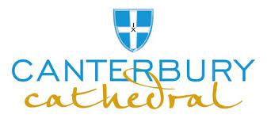
Group Refreshment Options
Refreshments will be served in our Community Space within our Visitor Centre.
Refreshments are available for groups of between 15-40 (If you wish to bring a larger group with catering please speak to us about available options in the Cathedral Lodge contact events@canterburycathedrallodge.org)
Your selection will be served Buffet-style, allowing you to move around the room and enjoy the Cathedral views. There will be some seating for those who would prefer not to stand, but there will be no waitress service available.
- Indicate your catering preference on the form below. We will then confirm availability of this date with you. Your date will not be confirmed until you receive notification from us.
- We require final numbers and any dietary requirements no less than 10 working days before your visit.
- You can pay for your refreshments in advance with a card (preferred) by calling 01227 865350. You may also use your Travel Trade voucher if you have credit facilities in place or pay at the Lodge on the day of your Visit.

Enjoy… | Consists of… | Price per person | Group Option (tick one) | Group Size | Date Required
Sandwich Buffet with Tea/ Coffee | Homemade Sandwiches with assorted Fresh Fillings accompanied by tea or coffee | £10.00
Danish Pastry | Delicious Danish Pastry with tea or coffee | £4.00
Tea and Cake | Cake with tea or coffee | £4.95
Cream Tea | 2 Scones, butter, jam and clotted cream | £7.50
Tea and Biscuits | Tea, coffee and biscuits | £3.50

Company Name……………………………………………………………………………………………………………………
Your Name………………………………………………… Contact Number…………………………………………
Email……………………………………………………………………………………………………………………………………
Address………………………………………………………………………………………………………………………………..

