# List of Safeguarding Contacts 2023

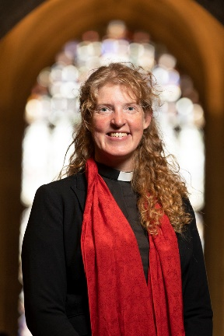

**Lead responsibility for safeguarding within the Cathedral community**

Canon Missioner, Rev’d Dr Emma Pennington: 01227 865228

E Mail: [emma.pennington@canterbury-cathedral.org](mailto:emma.pennington@canterbury-cathedral.org)

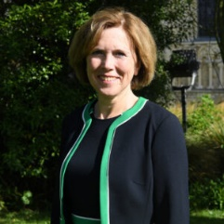 **Deputy Cathedral Safeguarding Lead**

Interim Receiver General, Kathryn Beldon: 5212

E Mail: [kathryn.beldon@canterbury-cathedral.org](mailto:kathryn.beldon@canterbury-cathedral.org)

**Deputy Cathedral Safeguarding Lead**

Vacancy



**Cathedral Safeguarding Advisers**

Fiona Coombs – 07548 232395 / [FCoombs@diocant.org](mailto:FCoombs@diocant.org)

Paul Brightwell – 07398 009951 / [PBrightwell@diocant.org](mailto:PBrightwell@diocant.org)

**Head of Human Resources**

**Operational responsibility for safeguarding children and young adults**

Lucy Stanton: 01227 865285

E mail: [lucy.stanton@canterbury-cathedral.org](mailto:lucy.stanton@canterbury-cathedral.org)



**Safeguarding Trainer**

Katy Harper: 01227 473565  
 [kharper@diocant.org](mailto:kharper@diocant.org).

**Report an emergency Safeguarding issue**

**Head Constable**

  Fred McCormack: 01227 866237

Constable’s Lodge, No 1 The Precincts

   E mail: [fred.mccormack@canterbury-cathedral.org](mailto:fred.mccormack@canterbury-cathedral.org)

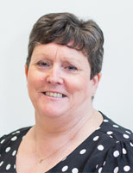 **Chair of Diocesan and Cathedral Safeguarding Advisory Panel**

Carol Iddon  
 [ciddon@diocant.org](mailto:ciddon@diocant.org)

**Mental Health First Aiders**

Tom Cooney: 2741

# 